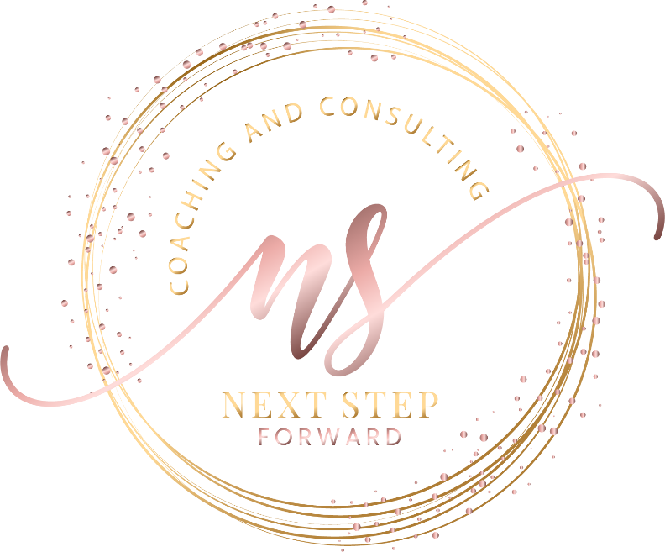

Next Step Forward

Kashaun Parker
Speaker Introduction
"Kashaun Parker has spent more than two decades helping organizations solve one of leadership's greatest challenges—turning strategy into measurable results. Throughout her career, she noticed a recurring pattern: organizations were making significant investments in growth, innovation, leadership, and transformation, yet many struggled to realize the value they expected. That observation became the foundation of her work. Today, Kashaun is the Founder and CEO of Next Step Forward, where she serves as a Business Advisor, Organizational Effectiveness Consultant, and keynote speaker. She works with executive leaders to strengthen strategic execution, improve organizational effectiveness, and help organizations create greater value from their strategic investments. Kashaun brings more than 20 years of business leadership experience, holds an MBA, and is currently pursuing her Doctorate in Business Administration with a specialization in Strategy and Innovation, where her research focuses on organizational value realization from innovation investments. Her engaging style, practical insights, and systems-thinking approach have helped leaders across industries think differently about leadership, execution, and organizational performance. Today, she's here to challenge conventional thinking, spark meaningful conversations, and leave you with practical ideas you can immediately put into action. Please join me in welcoming...
Kashaun Parker!"

This Page Is Intentionally Blank

