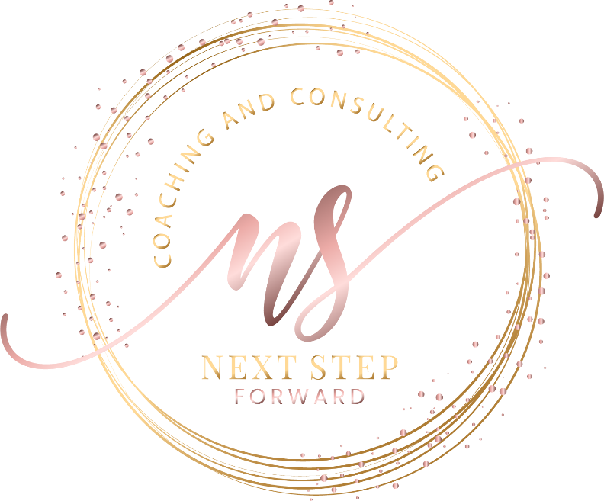

Next Step Forward

Kashaun Parker
WEBSITE & PROMOTIONAL COPY
Kashaun Parker
Business Advisor | Organizational Effectiveness Consultant | Keynote Speaker
Founder & CEO, Next Step Forward

Website: www.KParker.co
Email: info@KParker.co

Short Website Copy (50 Words)
Kashaun Parker is a Business Advisor, Organizational Effectiveness Consultant, and keynote speaker who helps executive leaders strengthen strategic execution and improve organizational performance. Through practical insights and real-world experience, she equips audiences with actionable strategies that help organizations turn strategy into measurable results.

Standard Website Copy (100 Words)
Kashaun Parker is the Founder and CEO of Next Step Forward, where she serves as a Business Advisor, Organizational Effectiveness Consultant, and keynote speaker. With more than 20 years of business leadership experience, she helps executive leaders improve organizational effectiveness by strengthening strategic execution, leadership alignment, and organizational performance. Kashaun's engaging presentations combine practical business insight with actionable strategies that help audiences think differently about leadership, execution, and creating measurable organizational results.

Extended Website Copy (250 Words)
Kashaun Parker is the Founder and CEO of Next Step Forward, a Business Advisor, Organizational Effectiveness Consultant, and keynote speaker dedicated to helping organizations strengthen strategic execution and improve organizational performance.
With more than 20 years of business leadership experience, Kashaun works with executive leaders to improve organizational effectiveness by aligning strategy, leadership, and execution. Her presentations challenge conventional thinking while providing practical frameworks that audiences can immediately apply within their organizations.
Recognized for her ability to simplify complex organizational challenges, Kashaun equips leaders with the clarity needed to strengthen collaboration, improve execution, and create greater value from strategic investments. Whether speaking at leadership conferences, corporate meetings, or association events, she delivers engaging presentations that inspire meaningful conversations and practical action.
Kashaun holds an MBA and is currently pursuing her Doctorate in Business Administration with a specialization in Strategy and Innovation, where her research focuses on organizational value realization from strategic innovation initiatives.

Promotional Copy
Join Business Advisor, Organizational Effectiveness Consultant, and keynote speaker Kashaun Parker as she shares practical insights to help leaders strengthen strategic execution, improve organizational effectiveness, and turn strategy into measurable organizational results.

This Page Is Intentionally Blank

