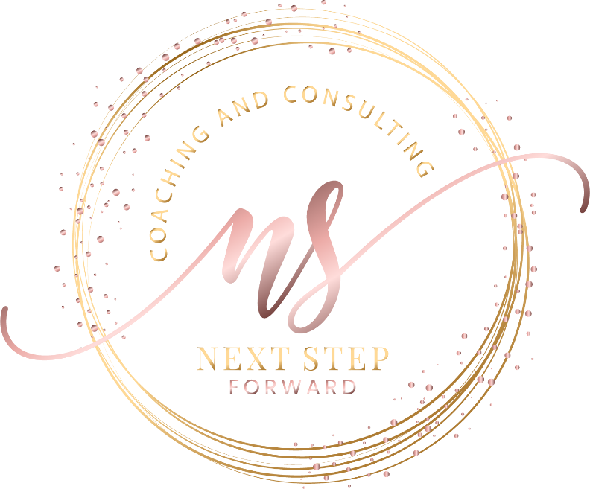

Next Step Forward

Kashaun Parker
SOCIAL MEDIA COPY
Kashaun Parker
Business Advisor | Organizational Effectiveness Consultant | Keynote Speaker
Founder & CEO, Next Step Forward
Website: www.KParker.co
Email: info@KParker.co

Announcement Post
We're excited to welcome Kashaun Parker to our event!
As a Business Advisor, Organizational Effectiveness Consultant, and keynote speaker, Kashaun helps executive leaders strengthen strategic execution, improve organizational effectiveness, and turn strategy into measurable organizational results.
Join us as she shares practical insights and actionable strategies designed to help leaders navigate complexity, improve execution, and create lasting organizational impact.
#Leadership #KeynoteSpeaker #OrganizationalEffectiveness #LeadershipDevelopment

Event Reminder
Just one week to go!
We're looking forward to welcoming Kashaun Parker as our keynote speaker. Kashaun will share practical strategies to help leaders strengthen strategic execution, improve organizational effectiveness, and create measurable organizational results.
We can't wait to see you there!
#Leadership #Conference #KeynoteSpeaker

Day-of Event
Today's the day!
We're excited to welcome Kashaun Parker as our keynote speaker. Get ready for practical insights, engaging conversation, and actionable ideas you can immediately apply within your organization.
We'll see you soon!
#Leadership #KeynoteSpeaker #Conference

Thank You Post
Thank you, Kashaun Parker, for an engaging and thought-provoking keynote. Your practical insights and actionable strategies challenged our thinking and inspired meaningful conversations about leadership, strategy, and organizational effectiveness.
Thank you to everyone who joined us!
#Leadership #Conference #OrganizationalEffectiveness

This Page Is Intentionally Blank

