

Next Step Forward

Kashaun Parker
Headshot
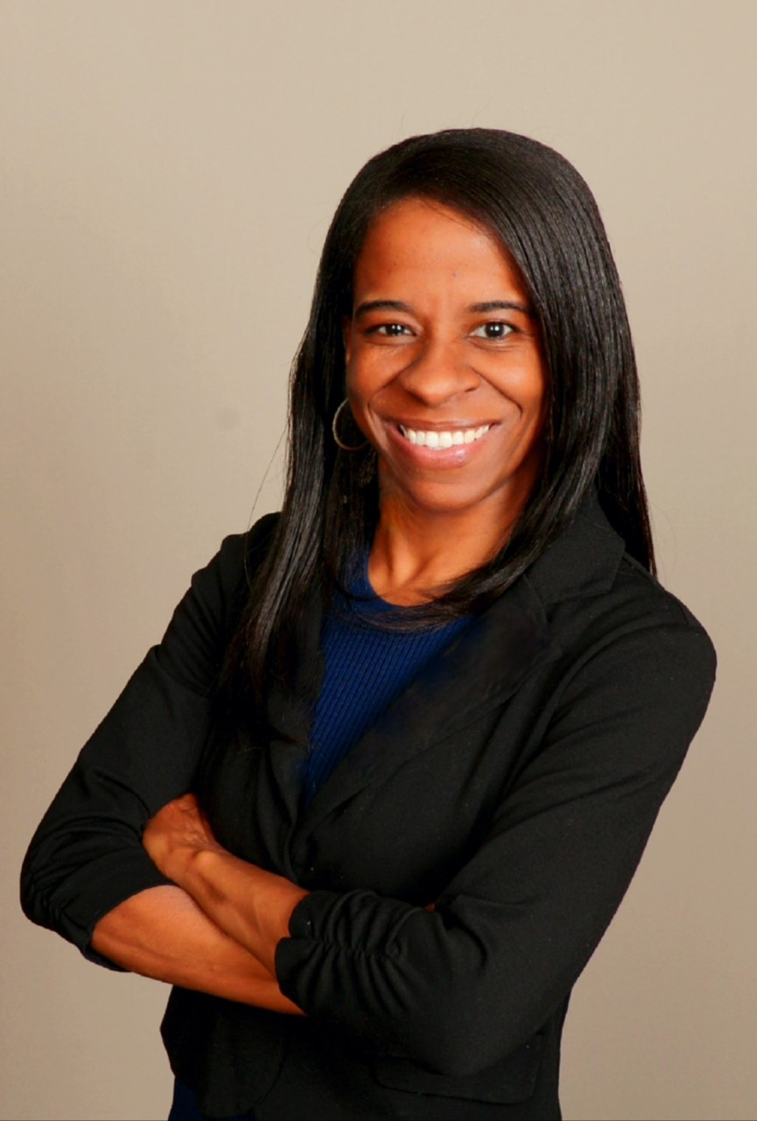This Page Is Intentionally Blank

